CSD317 Introduction to Database Systems
FITRACK_DB
Sports Complex Management System
Aayush Gupta (2310110645) | Sukhraj Singh (2310110310) | Anuran Basu (2310110053)

Objective-
To build a web-based system that manages memberships, court and gym bookings, employee schedules, and user profiles for a sports complex, simplifying day-to-day operations.
Features-
- User Registration & Login: Users securely sign up and log in.
- Membership Selection: Choose and view membership plans.
- Court Booking: Interactive court booking interface.
- Gym Plan Booking: Select from curated workout plans.
- Employee Schedule View: Schedule access for employees.
- Admin Panel: Manage users, employees, bookings, and equipment.

Technologies Used-
- Frontend: HTML, Tailwind CSS, Bootstrap 5, JavaScript
- Backend: Node.js, Express.js
- Database: MySQL

Database Design-
The database (fitrack_db.sql) includes various tables for handling:
- User and employee information
- Membership plans
- Court and gym booking records
- Gym trial booking
- Employee schedules

ER diagram-
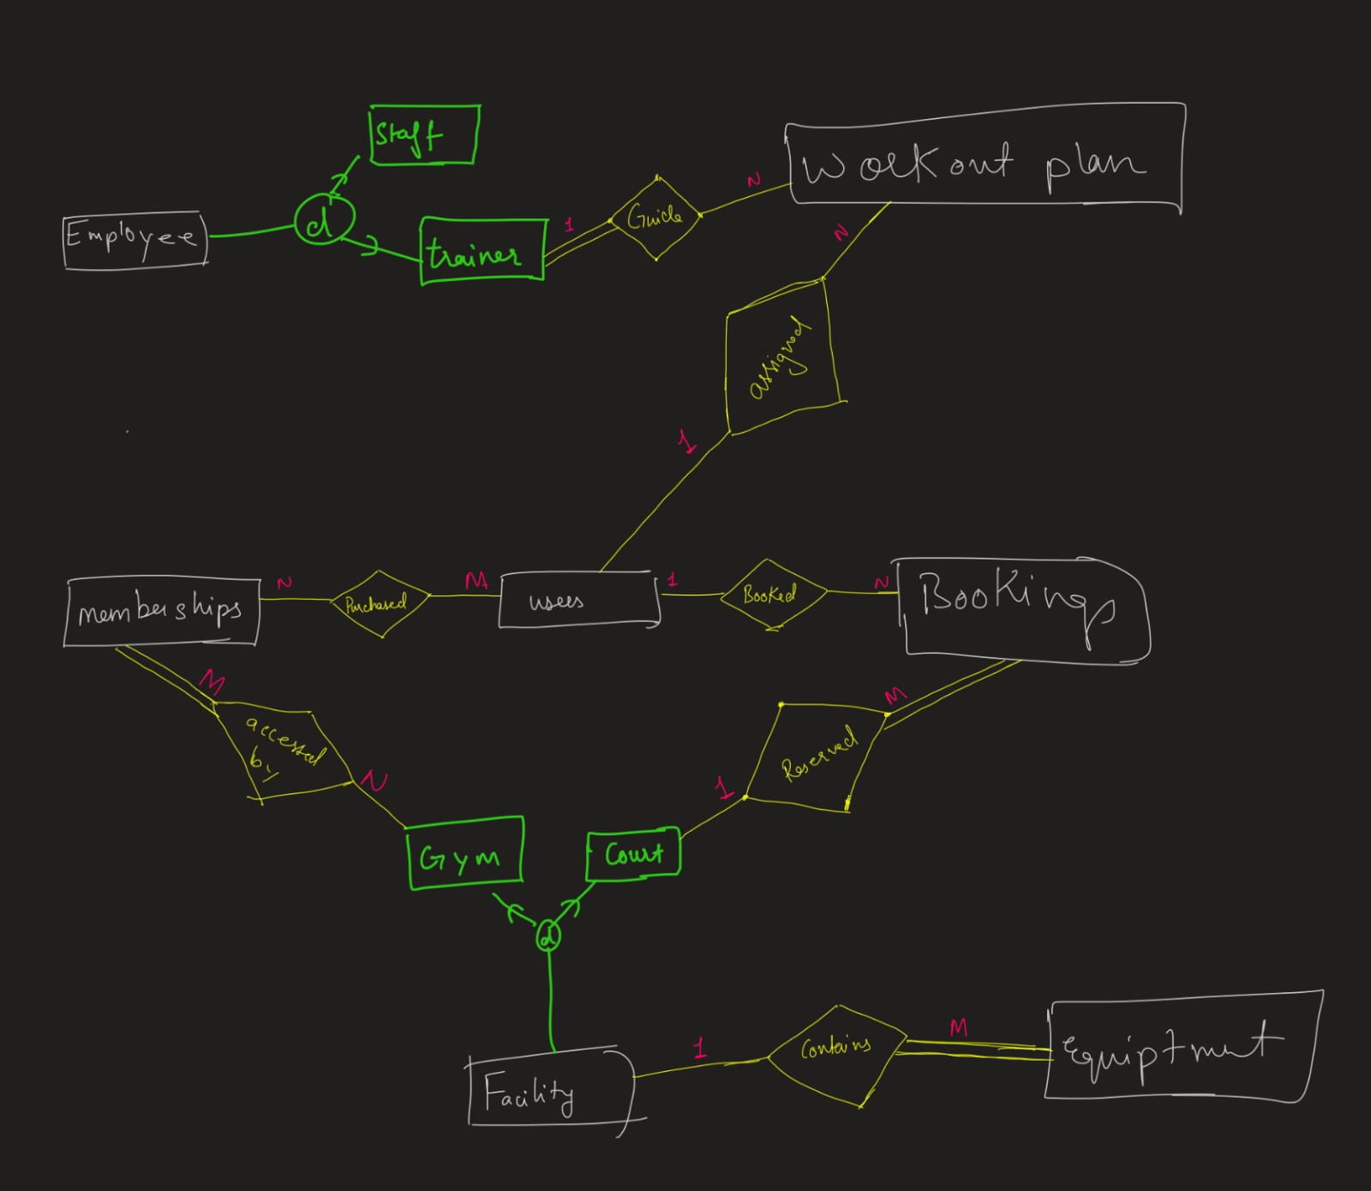

Relational model-
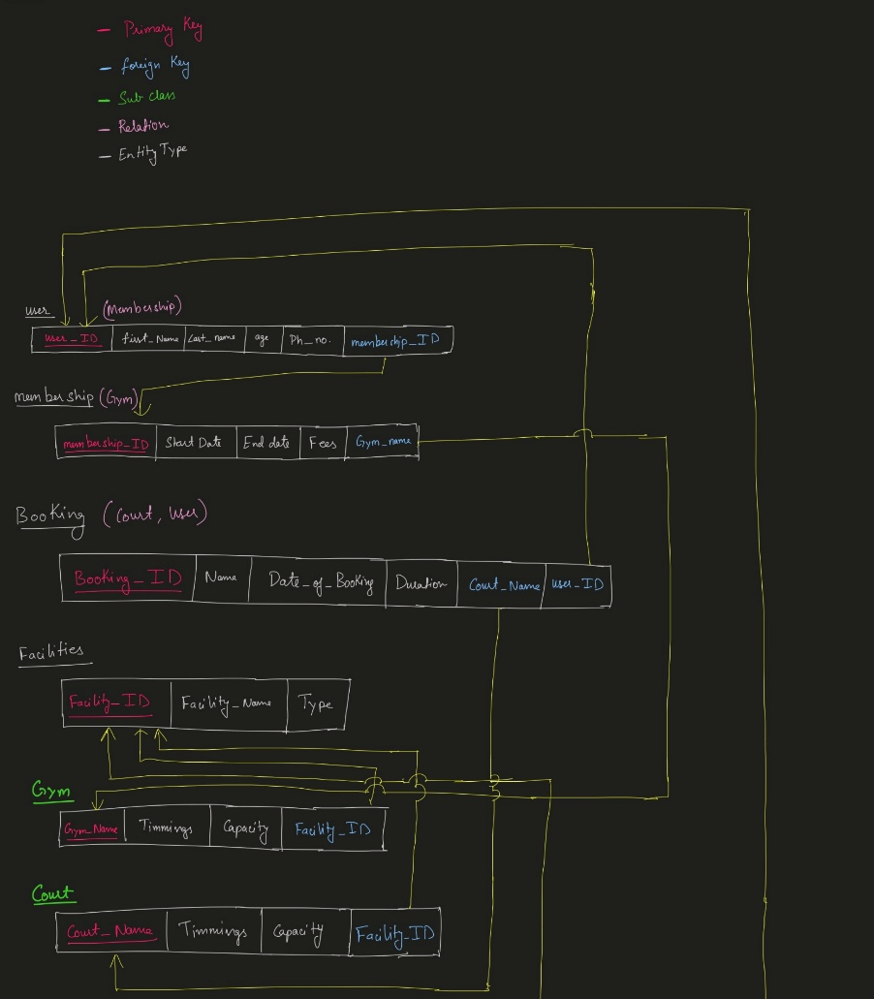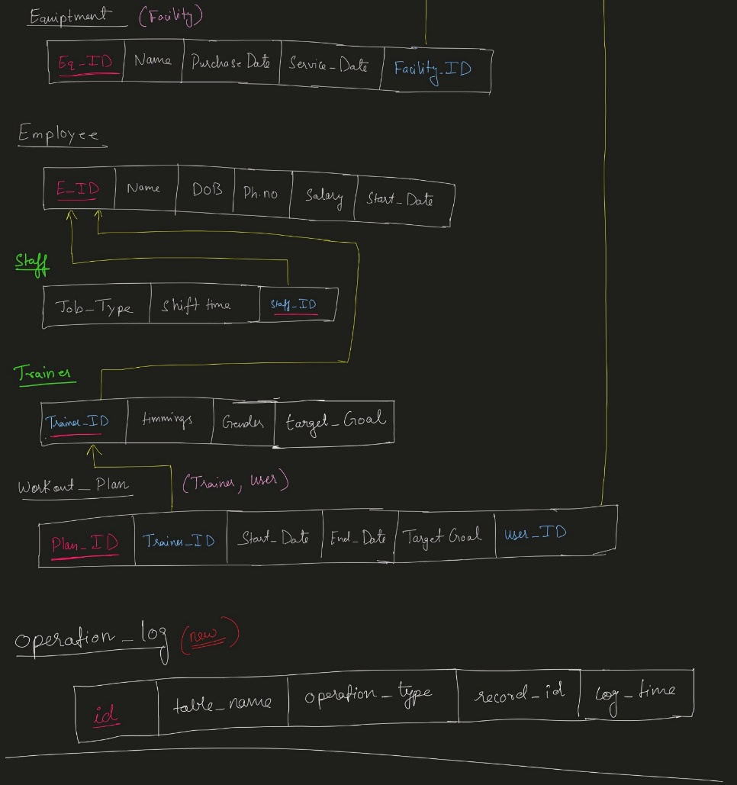
Functional Dependencies-
TABLE: 1: USER TABLE
- UserID → first name, last name, phone number, age, membership ID
- Phone_number → userID, first name, last name, age, membership ID (Assumption: Phone numbers are unique)
- Membership_ID → userID, first name, last name, phone number, age
- (First name, Last_name, Phone_number) → userID, age, membership ID

TABLE: 2 MEMBERSHIP TABLE
- Membership_ID → Start_Date, End_Date, Fees, Gym_Name

TABLE: 3 (BOOKING)
- Booking_ID → Name, Date_of_Booking, Duration, Court_Name, User_ID
- (Court_Name, Date_of_Booking, Duration) → Booking_ID

TABLE 4: FACILITY TABLE:
- Facility_ID → Facility_name, Type

TABLE 5: GYM TABLE:
- Gym_Name → Timings, Capacity, Facility_ID
- Facility_ID, Gym Name → Timings, Capacity

TABLE 6: COURT TABLE:
- Court_Name → Timings, Capacity, Facility_ID
- Facility_ID, Court_Name → Timings, Capacity

TABLE 7: EQUIPMENT TABLE:
- Eq_ID → Name, Purchase_Date, Service_Date, Facility_ID

TABLE 8: EMPLOYEE TABLE:
- Employee_ID → Name, DOB, Employee_Ph_No, Salary, Start_Date
- Employee_Ph_No → Employee_ID, Name, DOB, Salary, Start_Date
TABLE 9: STAFF TABLE:
- Staff_ID → Job_Type, Shift_Time

TABLE 10: TRAINER TABLE:
- Trainer_ID → Timings, Gender

TABLE 11: WORKOUT PLAN:
- Plan_ID → Trainer_ID, Start_Date, End_Date, Target_Goal, User_ID
- User_ID → Plan_ID

NORMALIZED TABLES AND SQL QUERIES
TABLES AND DESCRIPTIONS
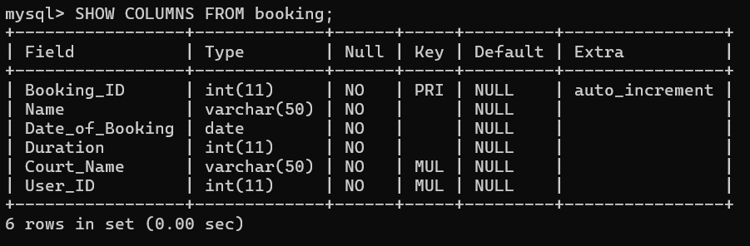
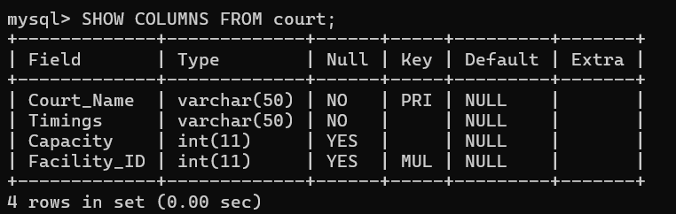
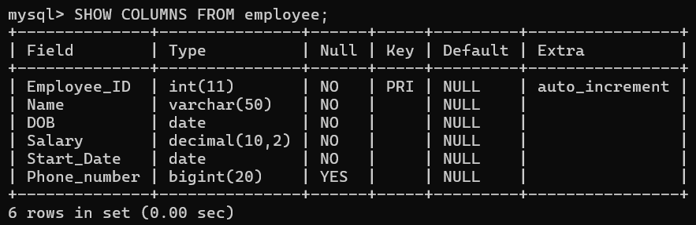
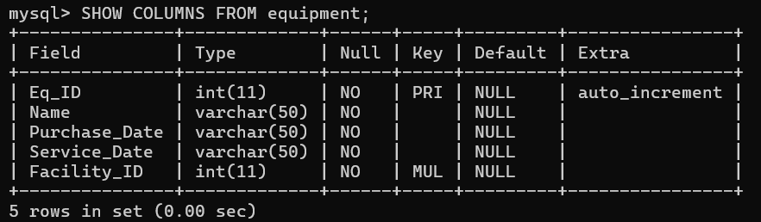
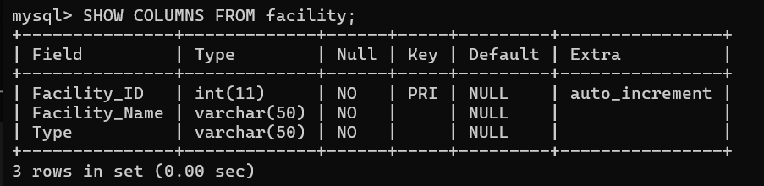
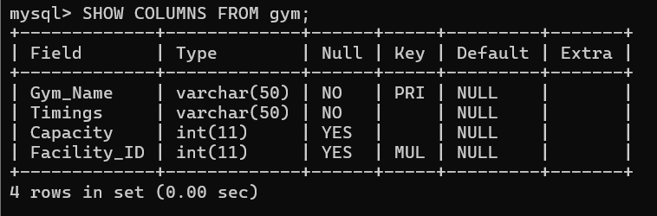
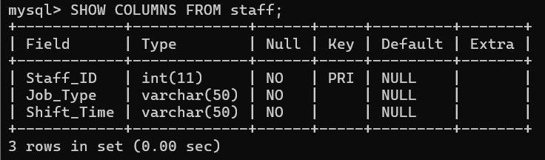
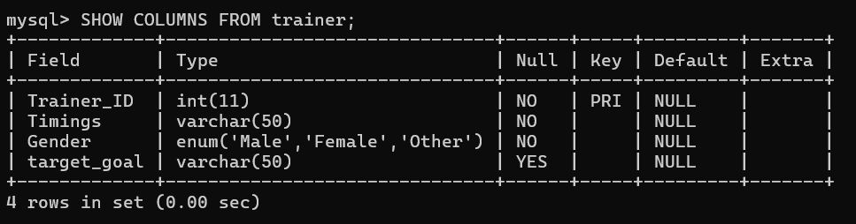
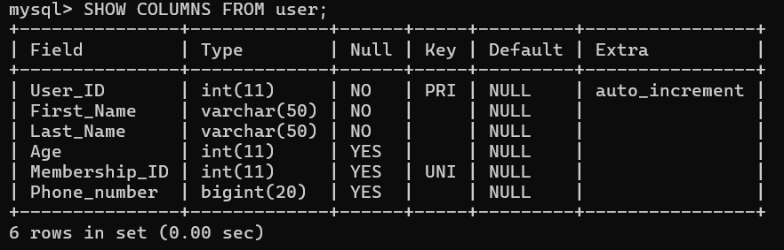
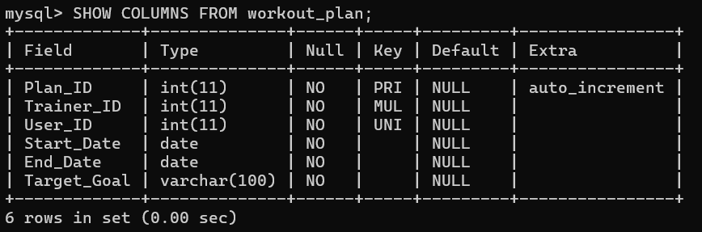
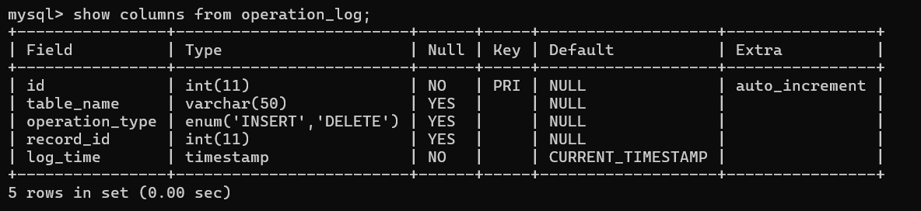

SQL QUERIES-
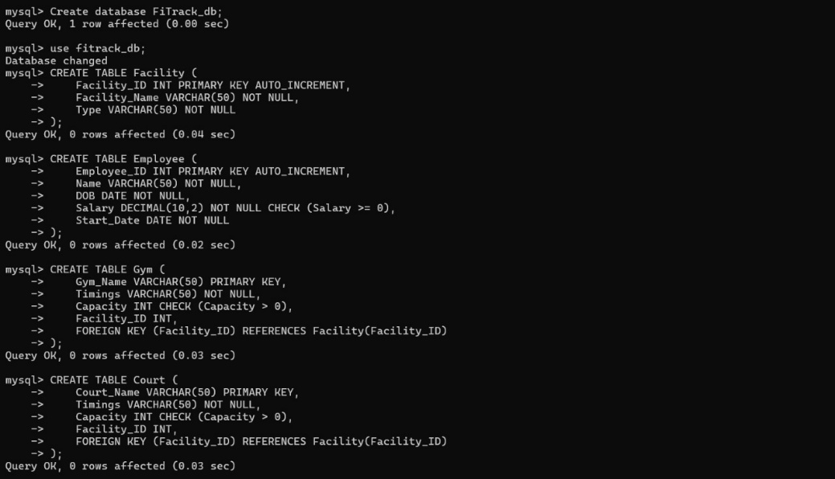
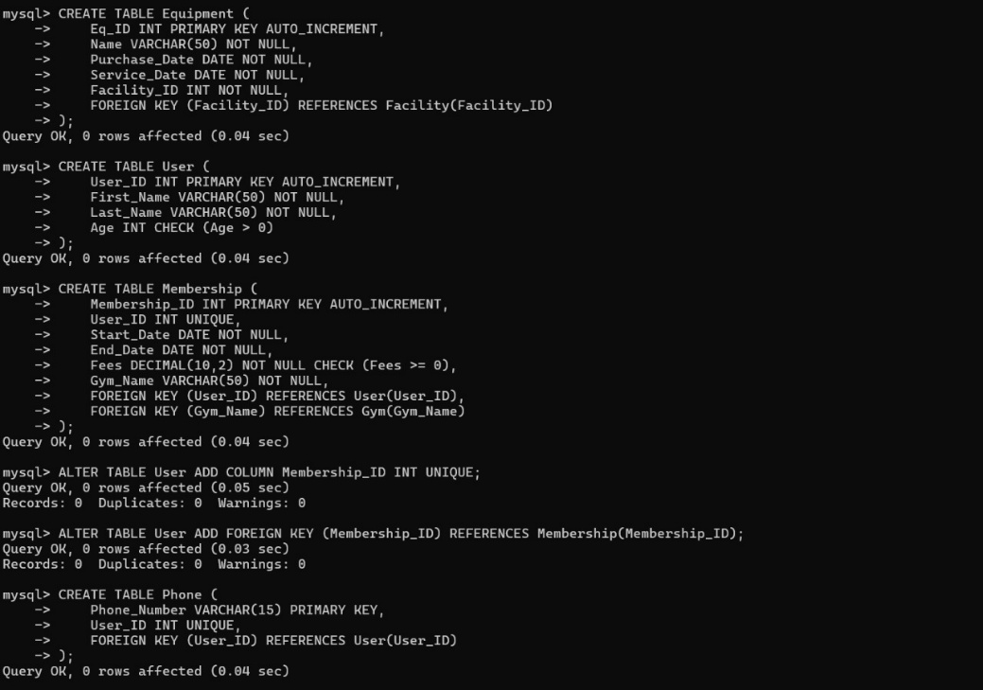
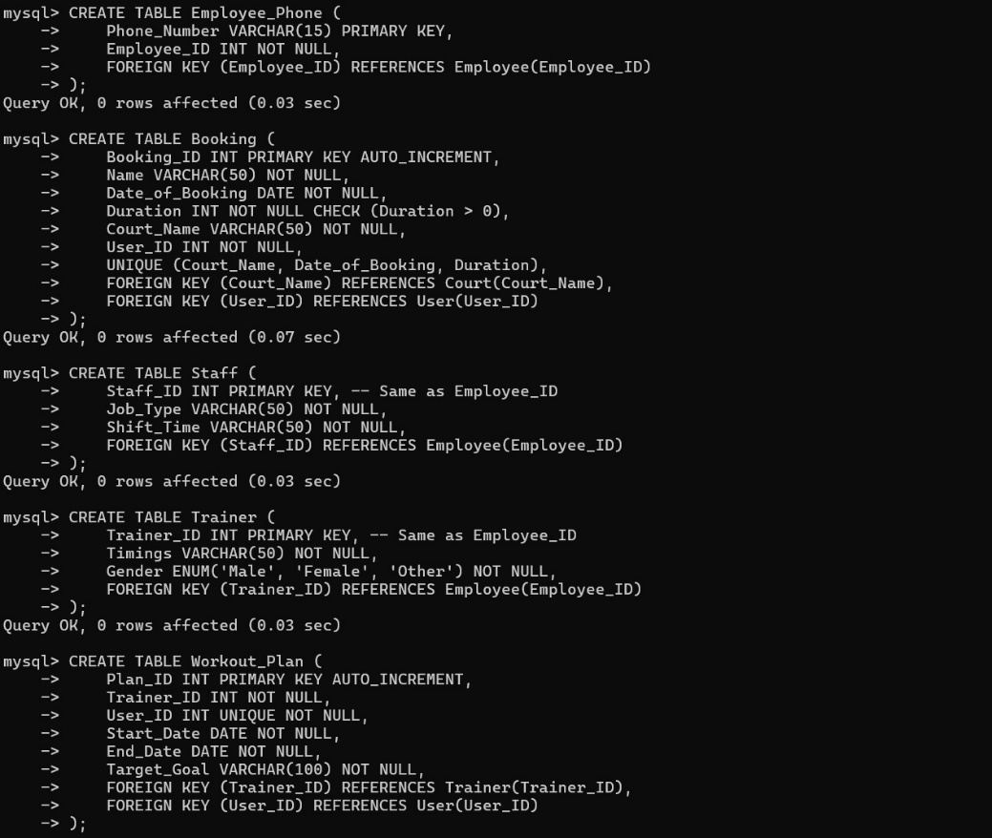
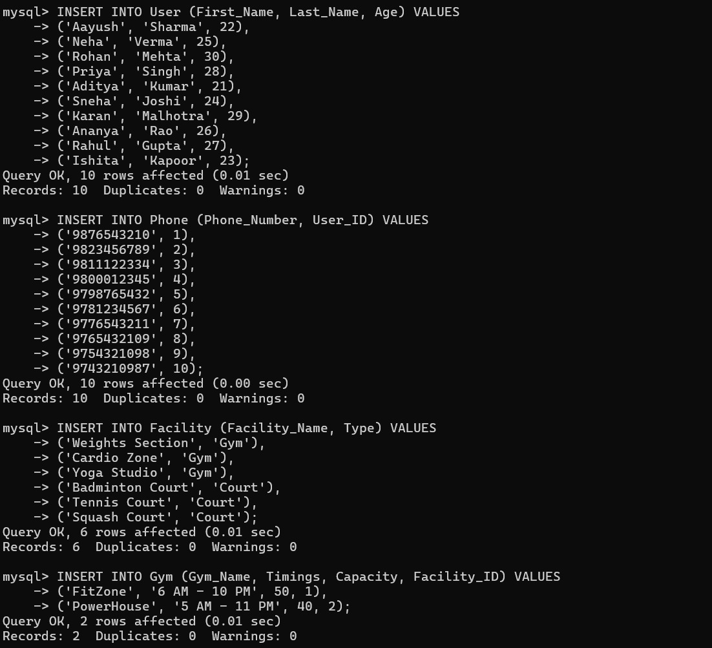
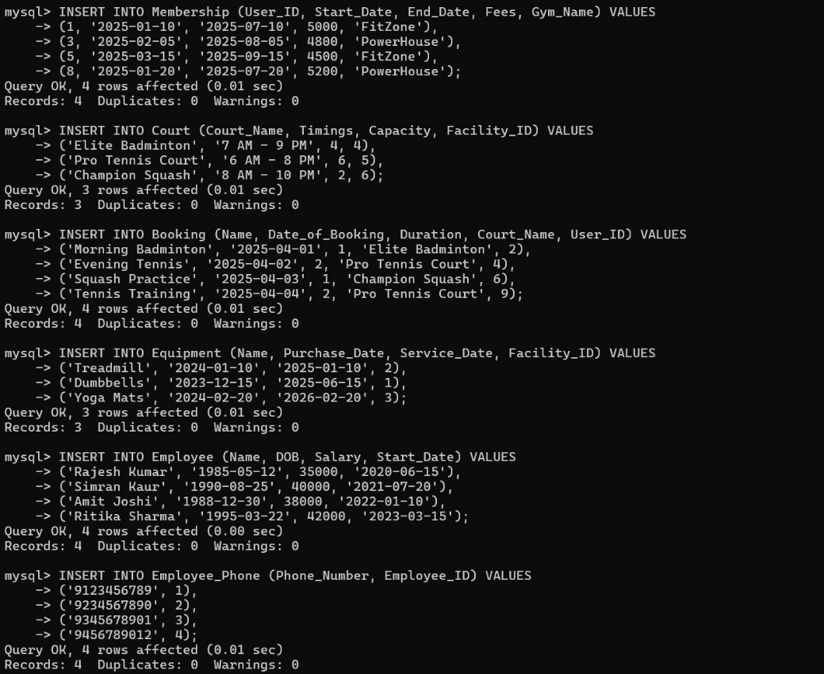
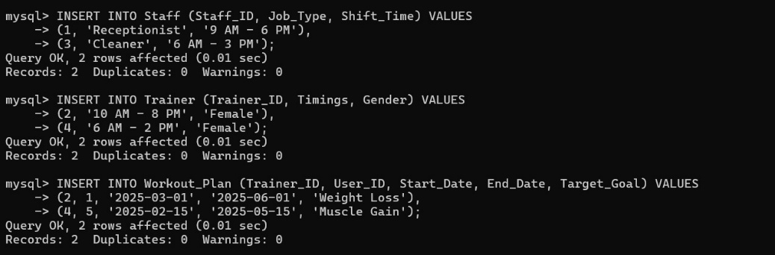
USER TABLE
Each attribute depends only on the primary key, and all multi-valued dependencies are removed.
User Table
- User_ID (PK) → First_Name, Last Name, Phone_Number (Unique), Age, Membership_ID (F.K)

MEMBERSHIP TABLE
- Membership_ID (PK) → User_ID, Start_Date, End_Date, Fees, Gym_Name (P.K)

BOOKING TABLE
No transitive dependencies exist.
- Booking_ID (PK) → Name, Date_of_Booking, Duration, Court_Name (F.K), User_ID (F.K)
- (Court_Name, Date_of_Booking, Duration) (Candidate Key) → Booking_ID

FACILITY TABLE
Already in 3NF, as Facility_ID uniquely identifies its attributes.
- Facility_ID (PK) → Facility_Name, Type

GYM TABLE
- Gym_Name (PK) → Timings, Capacity, Facility_ID (F.K)

COURT TABLE
Same normalization applies as for the Gym Table.
- Court_Name (PK) → Timings, Capacity, Facility_ID(F.K)

EQUIPMENT TABLE
Already in 3NF.
Eq_ID (PK) → Name, Purchase_Date, Service_Date, Facility_ID (F.K)

EMPLOYEE TABLE + Employee Phone number table
We separate Phone Numbers to ensure uniqueness.
- Employee_ID (PK) → Name, DOB, Salary, Start_Date
- Employee_Phone (PK) → Employee_ID, Phone_Number

STAFF TABLE
- Staff_ID (PK Which basically is EMPID _ name change) → Job_Type, Shift_Time

TRAINER TABLE
- Trainer_ID (PK Which basically is EMPID _ name change) → Timings, Gender

WORKOUT PLAN TABLE
- Plan_ID (PK) → Trainer_ID(P.K), Start_Date, End_Date, Target_Goal, User_ID(P.K)
- If each User has exactly one plan at a time:
  - User_ID (FK, Unique) → Plan_ID

Trigger implementation:
- we have used triggers to show all the operations performed in the operation-log to keep track of the operations performed on the table.
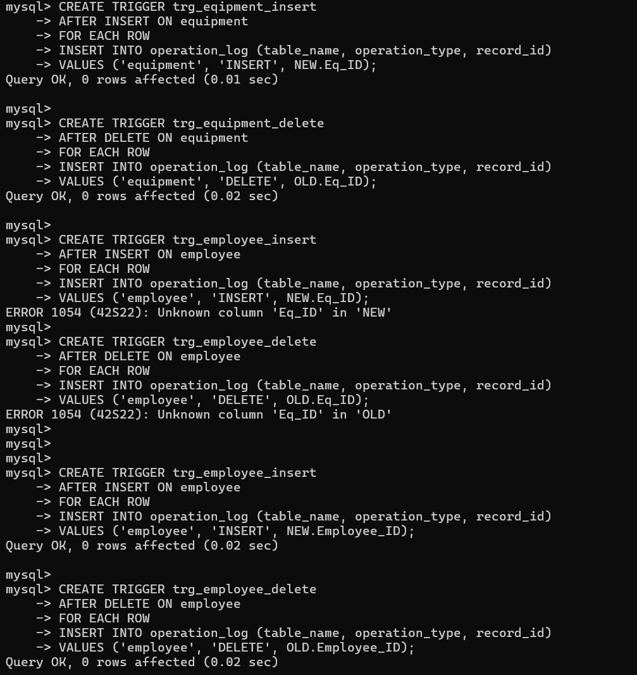

Operation log
- contains the record of operations performed on tables,
- fields: id, table_name, operation_type, record_id, log time
- log_time - keeps track of the exact time of an operation
- table_name – notes which table the operation is performed on

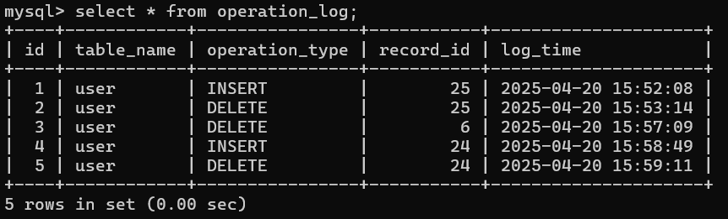

References
Frontend design reference- https://htmlburger.com/blog/modern-website-design-examples/
Mysql reference- https://dev.mysql.com/doc/
Documentations referred-
https://tailwindcss.com/
https://getbootstrap.com/
https://developer.mozilla.org/en-US/
Image reference- https://unsplash.com/
Icons reference- https://www.flaticon.com/
Debugging reference- https://chatgpt.com/

Limitations
- No payment gateway integration
- Admin dashboard lacks analytics/charting features
- No email confirmation system implemented

Future Enhancements
- Integrate a payment gateway for seamless membership purchases.
- Add admin and employee dashboards with access control.
- Implement email/SMS notifications for bookings and schedules.
- Improve UI/UX using frameworks like Vue or React.
- Use Firebase/Auth or JWT for secure login and session management.
- Include analytics/dashboard for usage insights.

